INDIA- CHINA TRADE RELATIONS

BY:-
ANISHA ARORA

FIFTH YEAR
B.BA.LL.B.(H)
UNIVERSITY OF PETROLEUM AND ENERGY STUDIES, DEHRADUN

7409427405
aroraanisha753@gmail.com

www.probono-india.com
20thAugust, 2020
Majority of the modern nations opened their economy towards the rest of the world. Their existence will be questioned on the absence of foreign trade. So now a day international trade is an important matter to every country and their goal is to maximize their benefit from foreign trade. Some of them may incur profit at the cost of others and vice versa. Just like others, India is also maintaining its trade relation with the rest of the world.
In this context it is an important question that who is the major trade partner of our country? What makes them in such a position?
The commencement of the present study is with these questions. When we go through the relevant literature in relation with India – China trade relationship in Indian context, it reveals that such studies dealing with same subject matter are very limited and that is why this study is very relevant in nature. The two giant economies in Asia namely India and China occupy some common elements like large territorial area, high population and separated by common border etc. By bilateral relationship we mean the exchange of goods and services between two nations. The economic relation between both countries occupies an important role in framing the strategic and cooperative partnership between these two countries. The objective of the present study is to analyse the different aspects of India- China economic and trade relations.
An over view of India - China relationship:
A discussion, we know that India and China are the fastest growing economies in the world commenced their bilateral trade relationship during 1950s. Both countries attained the recognition of international community for their role in international financial affairs. The People's Republic of China (PRC) was officially came in to existence on October 1, 1949, and India was the first non-communist nation who established an Embassy in China.The SED is a mechanism initiated in 2010 for the immediate discussion of any strategic or macroeconomic issues related to bilateral trade and the Financial Dialogue is formed in 2005 to strengthen the economic and trade cooperation, It reveals that China emanated as one of the most important trade partner of India. But when we look in to the balance of trade between these two countries, we can understand that it is still favourable to China due to the larger dissimilarities between the export and import. Even though we are trying to enter in to the Chinese market with variety of commodities, we are not able to compete with the Chinese products. Thus, “a cooperative and mutually beneficial relationship with China is inevitable for India to play a significant role in the Asian balance of power in the globalized era” (Aiyengar-2010) India has great potential in areas like biotechnology, IT, health, education, tourism, and financial sector. So now we are trying to open up Chinese market for these services through technical innovations and by understanding the sector specific information from China. On the period between 1st May to 30th November, 29 items are permitted to export and 15 are allowed to import. “China’s economic and commercial expansion is making it a crucial country in global trade and financial flows. The opportunities provided by the huge and growing Chinese market cannot be ignored by governments and corporations” (Sibal, A.K-2012).
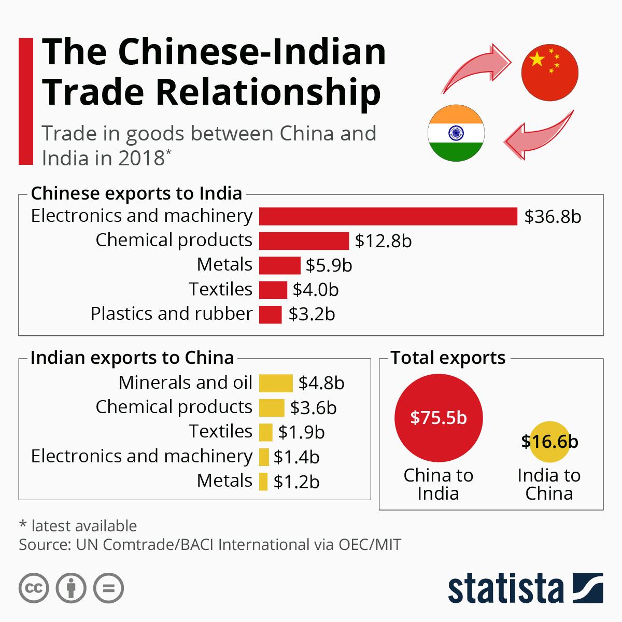Bilateral Trade
Bilateral trade between China and India touched US$89.6 billion in 2017–18, with the trade deficit widening to US$62.9 billion in China's favour. In 2017, the volume of bilateral trade between India & China stands at US$84.5 billion. This figure excludes bilateral trade between India & Hong Kong which stands at another US$34 billion.
The CCP General Secretary and President of China, Xi Jinping, was one of the top world leaders to visit New Delhi after Narendra Modi took over as Prime Minister of India in 2014. India's insistence to raise South China Sea in various multilateral forums subsequently did not help that beginning once again, the relationship facing suspicion from Indian administration and media alike.
Data and Methodology
The strengthened trade relationship between India and China had promoted several Indian companies to start their business operations in China. Such Indian enterprises are mainly engaged in banking and allied activities, IT and IT enabled services, trading, manufacturing etc in major cities like Guangzhou, Shenzhen, Zhejiang, Shanghai and Beijing. The major Indian enterprises operating in China are Dr. Reddy’s Laboratories, Matrix Pharma, Aurobindo Pharma, NIIT, Infosys, Bharat Forge, APTECH, TCS, Wipro, Essel Packaging, Mahindra Satyam, Suzlon Energy, Sundaram Fasteners, Reliance Industries, TATA Sons, Mahindra & Mahindra, Binani Cements, etc. Likewise several Chinese companies are also operating in India in the area of infrastructure and machinery constructions, IT and Hardware manufacturing, EPC projects in power sector etc. The major enterprises working in these fields are Shougang International, Sinosteel, Baoshan Iron & Steel Ltd, Chongqing Lifan Industry Ltd, Sany Heavy Industry Ltd, Sino Hydro Corporation, China Dongfang International, Huawei Technologies, TCL, ZTE, Haier, Shenyang Electric, Shanghai Electric, Dongfang Electric, Harbin Electric etc. Besides this many Indian banks like State Bank of India, Canara Bank, Axis Bank, Bank of Baroda, ICICI, Bank of India, Union Bank etc had started their banking operations in China. In 2011, Industrial and Commercial Bank of China have secured license for starting their banking business in India.
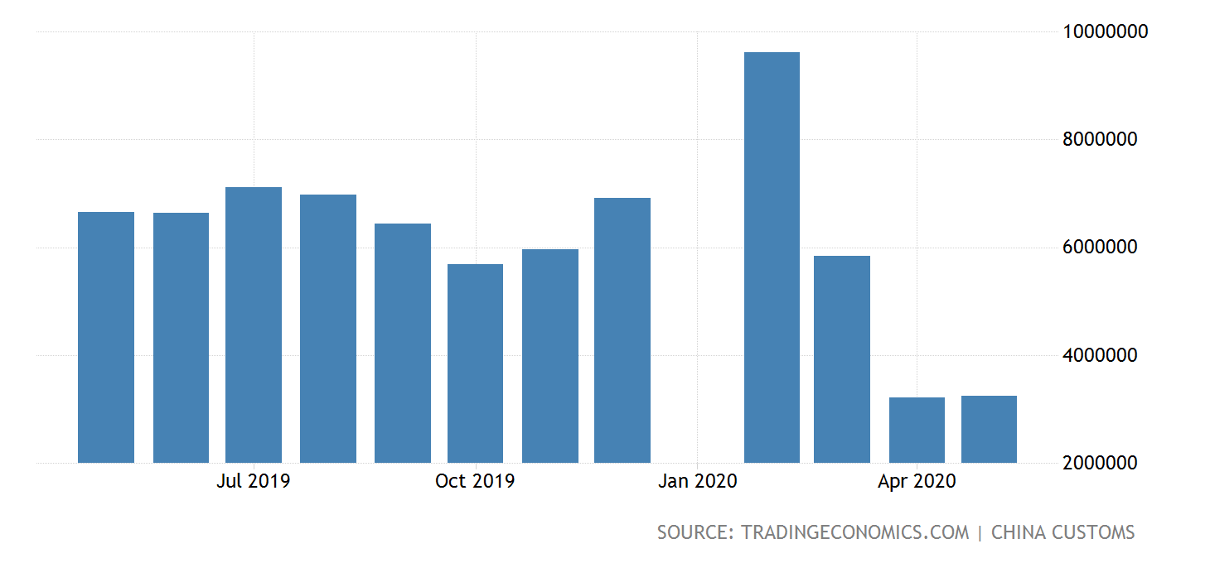

The data reveals the fact that, in 2000-01 the proportion of export and import of the country’s total volume was 1.46 and 2.57 respectively, that signifies there is no substantial difference between the bilateral trade relation between the countries at the very beginning of the 21st century. Even though the import is greater than export, the difference between the two is negligent. Such a trend had continued until 2005-06. Thereafter, it experienced a tremendous expansion in the volume of import with China and the gap between the country’s export and import started to increase and was mainly because of the export enhancing policy of China. In 2006 – 07 it was 6.5 and 8.38 respectively. This trend had continued every year and it created large disparity in export and import volume between both countries and finally it reached as 3.69 and 15.94 percentages in 2017 – 18. It showed an uneven pattern of growth for import and export of the country with china very recently. The following graph represents the trend of India-China export and import from 2000 to 2018.
Chinese Hooks In India’s Startups
Chinese funds and companies often route their investments in India through offices located in Singapore, Hong Kong, and Mauritius, a Gateway House report said. For example, Alibaba Group’s investment in Paytm came via Alibaba Singapore Holdings Pvt. These don’t get recorded in India’s government data as Chinese investments, the report said. “In several cases, the investment in India hasn’t been made in the name of the Chinese entity.
Conclusion
The India – China trade relationship started around six decades ago and now it became apex trade partner of India in terms of their total volume of trade. The data reveals that China is the largest importer of our country. Our export to china is quite scanty as we compare this share with China’s import. It is not a good sign to our economic development as the trade deficit is widening year by year. Constant attention is needed to reduce this deficit by expanding our export to China for the coming years. The institutions like India - China Business Council, India – China Trade Centre ,India China Economic and Cultural Council, India – China Chamber of Commerce and Industry etc. are the mutual institutions of both countries which enhancing the trade between them. When strategic summits held on this background, our representatives are always trying to boost up India’s condition to reduce our trade deficit. The mutual opening of banking and other business enterprises in both countries are appreciable as it can enhance our economic relationship.

References :-
- https://southasianvoices.org/india-china-economic-relations-an-assessment/
- https://www.eoibeijing.gov.in/economic-and-trade-relation.php
- https://www.bloombergquint.com/economy-finance/six-things-to-know-about-india-china-economic-relations
- http://researchersworld.com/ijms/vol6/issue3/Paper_02.pdf
- https://qz.com/india/1871164/india-china-clash-will-end-up-hurting-trade-ties-economies/
- https://tradingeconomics.com/china/exports-to-india
- https://www.phdcci.in/wp-content/uploads/2018/11/India-China-Trade-Relationship_The-Trade-Giants-of-Past-Present-and-Future.pdf
- https://www.nasdaq.com/news-and-insights
- https://en.wikipedia.org/wiki/Alibaba_Group
- https://en.wikipedia.org/wiki/China%E2%80%93India_relations
- https://www.treasury.gov/press-center/press-releases/Pages/jl2010.aspx
- https://archive.org/stream/internationallaw033123mbp/internationallaw033123mbp_djvu.txt
- https://www.livejournal.com/manage/settings/?cat=display
- https://en.wikipedia.org/wiki/China%E2%80%93India_relations
- https://en.wikipedia.org/wiki/China%E2%80%93India_relations
- https://www.state.gov/report/custom/8d7ce483b4
- https://www.sciencedirect.com/science/article/pii/S0970389614000688
- https://www.citationmachine.net/oscola/cite-a-website/archive.org/stream/worldrevolution00websgoog/worldrevolution00websgoog_djvu.txt

